# MQ2 Gas Sensor

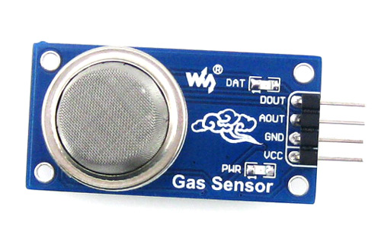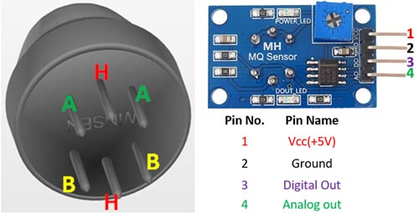

**MQ2 Gas sensor MQ2 Gas sensor Pinout**

### **Pin Configuration:**

|  |  |  |
| --- | --- | --- |
| **Pin No:** | **Pin Name:** | **Description** |
| **For Module** |  |  |
| 1 | Vcc | This pin powers the module, typically the operating voltage is +5V |
| 2 | Ground | Used to connect the module to system ground |
| 3 | Digital Out | You can also use this sensor to get digital output from this pin, by setting a threshold value using the potentiometer |
| 4 | Analog Out | This pin outputs 0-5V analog voltage based on the intensity of the gas |
| **For Sensor** |  |  |
| 1 | H -Pins | Out of the two H pins, one pin is connected to supply and the other to ground |
| 2 | A-Pins | The A pins and B pins are interchangeable. These pins will be tied to the Supply voltage. |
| 3 | B-Pins | The A pins and B pins are interchangeable. One pin will act as output while the other will be pulled to ground. |

### Features:

* Operating Voltage is +5V
* Can be used to Measure or detect LPG, Alcohol, Propane, Hydrogen, CO and even methane
* Analog output voltage: 0V to 5V
* Digital Output Voltage: 0V or 5V (TTL Logic)
* Preheat duration 20 seconds
* Can be used as a Digital or analog sensor
* The Sensitivity of Digital pin can be varied using the potentiometer

### Alternative MQ Gas sensors:

|  |  |
| --- | --- |
| Sensor Name | Gas to measure |
| MQ-2 | Methane, Butane, LPG, Smoke |
| MQ-3 | Alcohol, Ethanol, Smoke |
| MQ-4 | Methane, CNG Gas |
| MQ-5 | Natural gas, LPG |
| MQ-6 | LPG, butane |
| MQ-7 | Carbon Monoxide |
| MQ-8 | Hydrogen Gas |
| MQ-9 | Carbon Monoxide, flammable gasses |
| MQ131 | Ozone |
| [MQ135](https://components101.com/sensors/mq135-gas-sensor-for-air-quality) | Air Quality |
| MQ136 | Hydrogen Sulphide gas |
| [MQ137](https://components101.com/sensors/mq137-gas-sensor) | Ammonia |
| MQ138 | Benzene,Toluene,Alcohol, Propane, Formaldehyde gas, Hydrogen |
| MQ214 | Methane, Natural Gas |
| MQ216 | Natural gas, Coal Gas |
| MQ303A | Alcohol, Ethanol, smoke |
| MQ306A | LPG, butane |
| MQ307A | Carbon Monoxide |
| MQ309A | Carbon Monoxide, flammable gas |

### 

### MQ2 Equivalent sensors:

MQ-6, AQ-2, MQ-306A, AQ-3

### Selecting between Sensor type and module type

When it comes to measuring or detecting a particular Gas the **MQ series Gas sensors** are the most commonly used ones. These sensors can either be purchased as a module or as just the sensor alone. If you are trying to only detect (not measuring ppm) the presence of a gas then you can buy it as a module since it comes with an op-amp comparator and a digital out pin. But if you planning to measure the ppm of a gas it is recommended to buy the sensor alone (without module).

### Where to use MQ-2 Gas sensor:

The **MQ-2 Gas sensor** can detect or measure gasses like LPG, Alcohol, Propane, Hydrogen, CO and even methane. The module version of this sensor comes with a Digital Pin which makes this sensor to operate even without a microcontroller and that comes in handy when you are only trying to detect one particular gas. When it comes to measuring the gas in ppm the analog pin has to be used, the analog pin also TTL driven and works on 5V and hence can be used with most common microcontrollers.

So, if you are looking for a sensor to detect or measure gasses like LPG, Alcohol, Propane, Hydrogen, CO and even methane with or without a microcontroller then this sensor might be the right choice for you.

### How to use MQ-2 Sensors to detect gas:

Using an MQ sensor it detects a gas is very easy. You can either use the digital pin or the analog pin to accomplish this. Simply power the module with 5V and you should notice the power LED on the module to glow and when no gas it detected the output LED will remain turned off meaning the digital output pin will be 0V. Remember that these sensors have to be kept on for pre-heating time (mentioned in features above) before you can actually work with it. Now, introduce the sensor to the gas you want to detect and you should see the output LED to go high along with the digital pin, if not use the potentiometer until the output gets high. Now every time your sensor gets introduced to this gas at this particular concentration the digital pin will go high (5V) else will remain low (0V).

You can also use the analog pin to achieve the same thing. Read the analog values (0-5V) using a microcontroller, this value will be directly proportional to the concentration of the gas to which the sensor detects. You can experiment with this value and check how the sensor reacts to different concentration of gas and develop your program accordingly.

### How to use the MQ-2 sensor to measure PPM:

If you are looking for some accuracy with your readings then measuring the PPM would be the best way to go with it. It can also help you to distinguish one gas from another. So, to measure PPM you can directly use a module. A basic wiring for the sensor from datasheet is shown below.

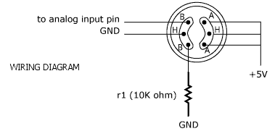

The procedure to measure PPM using MQ sensor is the same but few constant values will vary based on the type of MQ sensor used. Basically, we need to look into the (Rs/Ro) VS PPM graph given in the datasheet (also shown below).

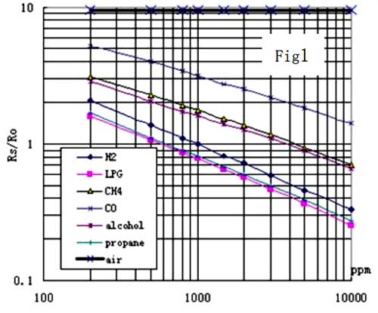

The value of Ro is the value of resistance in fresh air and the value of Rs is the value of resistance in Gas concentration. First, you should calibrate the sensor by finding the values of Ro in fresh air and then use that value to find Rs using the formulae

 Formula for finding resistance of sensor

Once we calculate Rs and Ro we can find the ratio and then use the graph shown above we can calculate the equivalent value of PPM for that particular gas.

### **Applications:**

* Detects or measure Gases like LPG, Alcohol, Propane, Hydrogen, CO and even methane
* Air quality monitor
* Gas leak alarm
* Safety standard maintenance
* Maintaining environment standards in hospitals

### **2D model of MQ-2 Gas sensor:**

If you purchased sensor then you can use the following dimensions to create your own PCB for your application

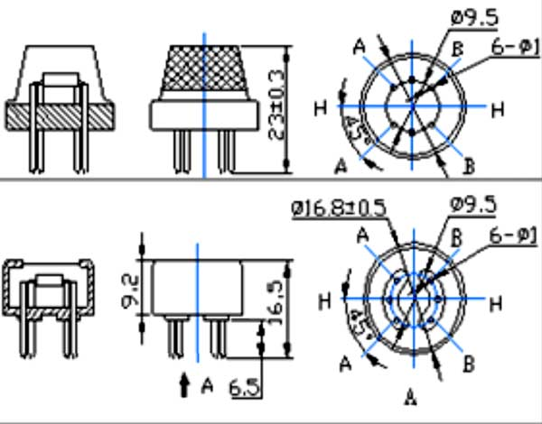

### **How does it Work with Arduino?**

The voltage that the sensor outputs change accordingly to the smoke/gas level that exists in the atmosphere. The sensor outputs a voltage that is proportional to the concentration of smoke/gas.

In other words, the relationship between voltage and gas concentration is the following:

* The greater the gas concentration, the greater the output voltage
* The lower the gas concentration, the lower the output voltage

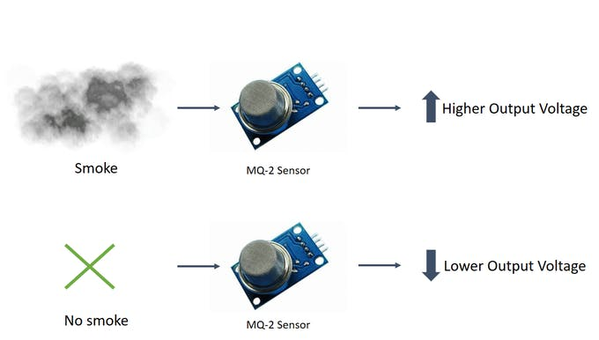

*Working Mechanism*

The output can be an analog signal (A0) that can be read with an analog input of the Arduino or a digital output (D0) that can be read with a digital input of the Arduino.

So, before jumping into the coding part, let's check whether we've assembled all the necessary hardware components.

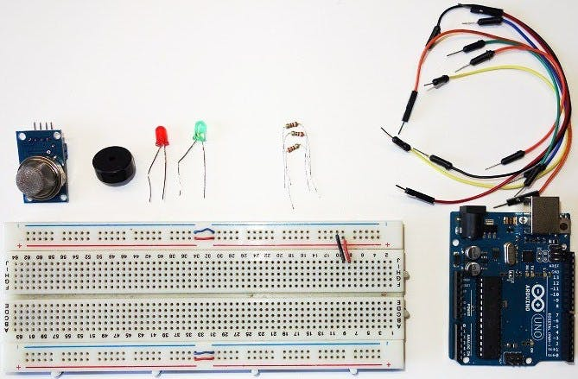

*Hardware Components*

Kindly refer to the connection schematic attached below. After you've wired all the components properly, it's time to upload the necessary code.

##### MQ-2 sensor code Arduino

After setting up the hardware components properly, flash this code into your Arduino.  
Feel free to adjust the variable " sensorThres " with a different threshold value.

int redLed = 12;

int greenLed = 11;

int buzzer = 10;

int smokeA0 = A5;

int sensorThres = 400; // Your threshold value

void setup() {

pinMode(redLed, OUTPUT);

pinMode(greenLed, OUTPUT);

pinMode(buzzer, OUTPUT);

pinMode(smokeA0, INPUT);

Serial.begin(9600);

}

void loop() {

int analogSensor = analogRead(smokeA0);

Serial.print("Pin A0: ");

Serial.println(analogSensor);

// Checks if it has reached the threshold value

if (analogSensor > sensorThres)

{

digitalWrite(redLed, HIGH);

digitalWrite(greenLed, LOW);

tone(buzzer, 1000, 200);

}

else

{

digitalWrite(redLed, LOW);

digitalWrite(greenLed, HIGH);

noTone(buzzer);

}

delay(100);

}

DOWNLOAD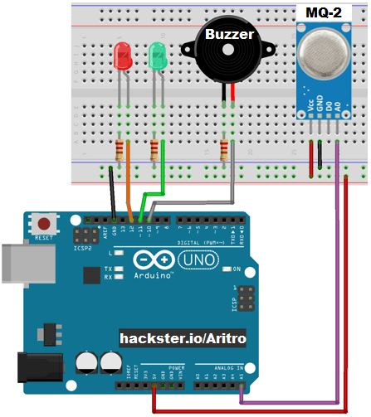

##### *Connection schematic diagram*